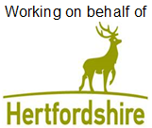

**‘Please ensure you have moved your car on the date below’**

**Resurfacing works in High Street, Puckeridge**

Works will be carried out **from outside The Crown and Falcon to the junction of Cambridge Road**

On **Monday 23 October 2023** to **Thursday 26 October 2023**

Works between **9:30am** and **4:00pm**

We are writing to tell you about works we’ll be undertaking in your area.

**What you need to do:**

* If you need to use your vehicle, please make sure you move it outside the road closure area shown on this letter, at least 30 minutes before we are due to start working.

**What you need to know:**

* **Vehicles may not be allowed access through the road closure during the works, except for emergency vehicles. We are unable to provide information of which part of the road will have access and when. Please speak to the on-site team on the day who will be able to advise on access.**
* Please refer to the yellow signboards on your street to see the exact dates, timings and permit number. Any date changes to these works will be communicated on the yellow signboards at either end of your street and at [www.hertfordshire.gov.uk/roadclosures](http://www.hertfordshire.gov.uk/roadclosures)
* These works are weather dependent and may be postponed if poor weather is forecast.
* Details of any disruptions to bus services can be found at [www.intalink.org.uk/timetables](http://www.intalink.org.uk/timetables) (search for your service). If you're unable to find this information please call our customer service centre on 0300 123 4050.
* All local businesses will be open as usual.

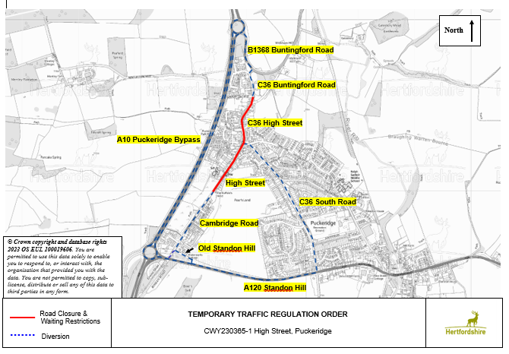

**Further information:**

* The permit number for these works is ***BA0080000007963*** full details can be found at [one.network](http://one.network)
* If you have any special needs or circumstances, please contact ***Eurovia – 07703 796403*** (during office hours) at ***hcc.comms@eurovia.co.uk*** or CSC on 0300 123 4047 or email us at [cschighways@Hertfordshire.gov.uk](mailto:cschighways@Hertfordshire.gov.uk)

We understand these works may be an inconvenience to you, however, we ask you to support us as we make the necessary improvements.

**For live traffic information and news across Hertfordshire, please follow us on social media and subscribe to our UpdateMe bulletins.**



@HertsHighways @HertsHighways @Herts_Highways