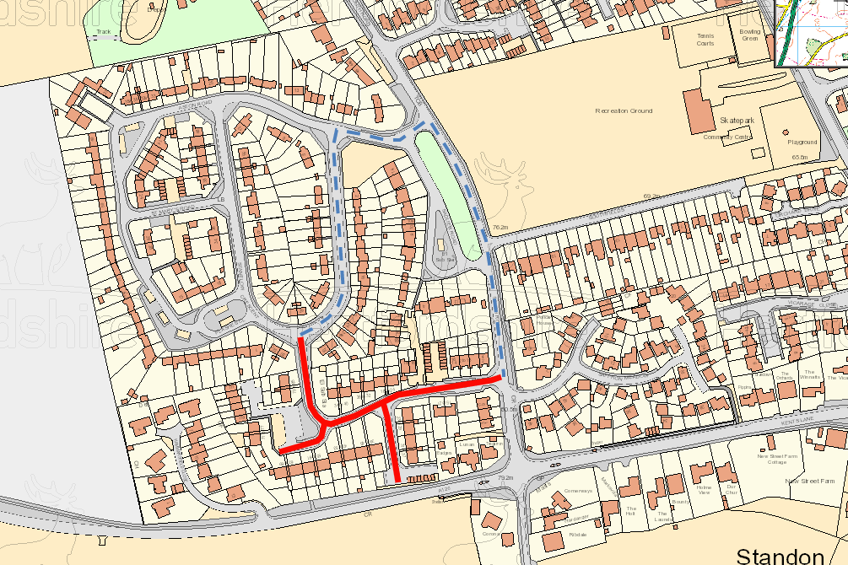

**North**

**TEMPORARY TRAFFIC REGULATION ORDER**

**CWY240158-a Gauldie Way**

Ferryhills Close

Road Closure &

Waiting Restrictions



**Aston Road**

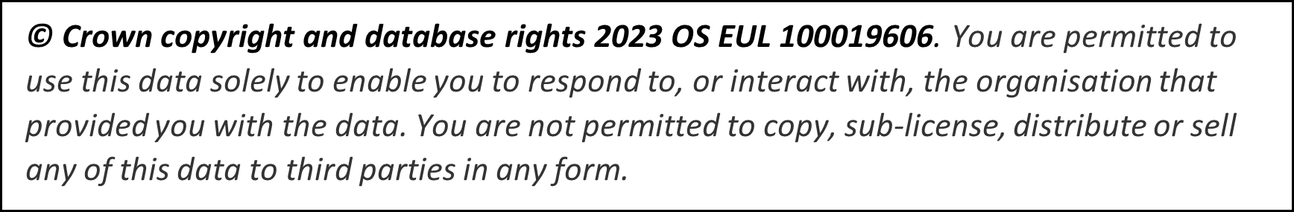

**Gauldie Way**

**Stanelow Crescent**

Diversion

**South Road**