|  |  |
| --- | --- |
| Risk Assessment ref: | SPC: RA park - 01 |
| Assessor: | Cllr R Boxall, on behalf of Standon Parish Council |
| Date: | 08/07/2020 |
| Review date: | 08/10/2020 or sooner subject to HM Government instruction |

|  |  |
| --- | --- |
| Document title: | Risk assessment document for managing COVID-19. |
| Scope of assessment: | Assessment of Skate & Play park, to allow for the safe re-opening following closure for COVID-19 |
| Location: | Skate & Play park, located off Station Road Puckeridge, SG11 1TF. |

Overview:

The following assessment has been carried out using advice and guidance from the *Register of play Inspectors International* and HM Government.

The assessment has identified that the following categories of individuals may be at harm:

* Adult / child – public
* Vulnerable Adult / child – public
* Extremely vulnerable adult / child – public
* Contractor / employed staff (SPC) – vegetation management, play equipment maintenance, refuse cleaners

The layout and design of the skate park and play park are shown on the plan below:

Access gates denoted by orange bars.

The play park is enclosed by a metal railing style fence with 3 pedestrian access points. The majority of this fencing is low level, except for the sections which adjoin the highway.

None of the access gates have locks. The fence could be breached easily by adults climbing over.

The skate park area is not fenced off.

All play apparatus is separated by at least 2m.

There are 6 x benches and a communal shelter with bench seating.

The majority of the apparatus is constructed from metal (stainless, galvanised or painted) with a combination of rubberised, rope or timber products as accessories.

The climbing frames and shelter are mainly of timber construction.

There are 3 x refuse bins located in the park(s) immediate location.

There are no toilet / hand-washing facilities on site.

Items of play apparatus:

* Skate ramp x 4
* Skate bar x 2
* Basketball frame
* Small play frame
* Small play house
* Baby swings
* See-saw
* Large climbing frame and balance apparatus
* Large slide and built in tunnel
* Basket swing
* Large swings
* Zip line
* Round-about
* “Witches hat” round-about
* Aerial spinner (hanging bar which rotates)
* Sound/speaker tube
* Puzzle board
* 3 in a row board
* Hop-scotch
* Balance board
* Sprung ride-on seats

Conclusion:

It should be noted that during the assessment, a significant number of adults/children were observed using the parks.

Historically the park has had a high volume of users, which typically increase in summer months and when the adjacent schools on Station road are operating normally.

Physical Closure of the skate / play park is assessed as impractical due to the open layout and low height fencing.

The layout does not lend itself to being controlled by a one-way pedestrian system due to the multiple entry/exit points.

A booking system to limit and control users is not practical due to the open design and uncontrolled entry points.

Cleaning of the play apparatus would be possible but given the number of different materials, amount of apparatus and the potential volume of users this would be impractical to achieve with any certainty that the cleaning is effective. The financial burden of this would be prohibitively expensive.

Employees / contractor staff who are carrying out maintenance tasks should produce and provide their own risk assessment and advise Standon Parish Council, of their control methods. It is recommended that the play area is temporarily closed whilst maintenance activities take place.

Provision of hand sanitiser and cleaning products to users is feasible but given the potential volume of users and lack of facilities to securely control the supply it is deemed impractical to do so. The financial burden of this would be prohibitively expensive.

It is recommended that signage is provided at suitable positions within the play areas to advise users of the COVID-19 hazard and methods to control and limit the spread of the disease.

Users should be encouraged to maintain social distancing and refrain from using the play area / apparatus at peak times.

Users should be encouraged to provide their own cleaning & hygiene products.

It is recommended that the above advice and instruction be added to the Standon Parish Council website.

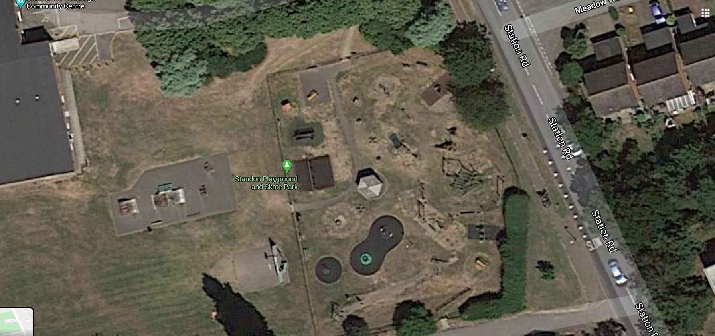

|  |  |  |
| --- | --- | --- |
| **Catch it** | **Bin it** | **Kill it** |
| **DO NOT – touch your eyes, nose or mouth** | **Symptoms- cough, fever, breathing difficulties** | **Remember to wash your hands for 20 seconds** |

|  |  |  |  |  |  |  |  |  |  |  |  |  |  |  |  |  |  |  |  |  |  |  |  |  |  |  |  |  |  |  |  |  |  |  |  |  |  |  |  |  |  |  |  |  |  |  |  |  |  |  |  |  |  |  |  |  |
| --- | --- | --- | --- | --- | --- | --- | --- | --- | --- | --- | --- | --- | --- | --- | --- | --- | --- | --- | --- | --- | --- | --- | --- | --- | --- | --- | --- | --- | --- | --- | --- | --- | --- | --- | --- | --- | --- | --- | --- | --- | --- | --- | --- | --- | --- | --- | --- | --- | --- | --- | --- | --- | --- | --- | --- | --- |
| |  |  |  |  |  |  |  | | --- | --- | --- | --- | --- | --- | --- | | **Severity** | **5** | **Death/ prosecution** |  |  |  |  | | **4** | **Major injury/ long term disability- illness/major pollution incident** | | | | | | **3** | **Major injury** | | |  |  | | **2** | **Minor injury** | | | | | | **1** | **Trivial injury** | | |  |  | | |  |  |  |  |  | | --- | --- | --- | --- | --- | | **Occurrence** | **5** | **Definite** |  |  | | **4** | **Near Certain/ regular** | | | | | **3** | **Likely/ irregular** | | | | **2** | **Occasional/ possible** | | | | | **1** | **Never/ very unlikely** | | | |  |

|  |  |  |  |  |  |  |  |  |
| --- | --- | --- | --- | --- | --- | --- | --- | --- |
| **Hazard-Task (COVID 19)** | **How will persons be affected** | **S** | **O** | **IR** | **Control measures** | **S** | **O** | **RR** |
| Exposure from others | Encountering family / friends who are infected | 5 | 4 | 20 | • Good Hygiene practices carried out by all family members  • Good communications between family members  • Good awareness of symptoms  • If family or friends make you aware, they are showing signs of infection – distance yourself  • If you or your close family show signs of infection – isolate yourself in line with Public Health England advice   * Increase awareness – SPC website * Employees /contractors to comply with their own RA & safe system of work | 5 | 1 | 5 |
| Exposure from others | Possible contact with infected persons whilst accessing - egressing park | 5 | 4 | 20 | **Social Distancing**   * Social Distancing - Reducing the number of people to allow a distance of 2 metres, where possible, as recommended by the Public Health Agency   • Where possible route is to be chosen to ensure least possible interaction with other persons.   * Increase awareness – SPC website * Employees /contractors to comply with their own RA & safe system of work | 5 | 1 | 5 |
| Contaminated structures | Touching play apparatus | 5 | 4 | 20 | **Cleaning**   * Frequently cleaning and disinfecting objects and surfaces that are touched regularly particularly in areas of high use. Parents, Guardians and users of the gym equipment should be encouraged to clean the equipment before and after use by way of signage * Increase awareness – SPC website * Employees /contractors to comply with their own RA & safe system of work | 5 | 1 | 5 |
| Exposure from Others | Lack of facilities (i.e. Soap/ Sanitiser/ Water) | 5 | 4 | 20 | **Cleaning**   * Frequently cleaning and disinfecting objects and surfaces that are touched regularly particularly in areas of high use. Parents, Guardians and users of the gym equipment should be encouraged to clean the equipment before and after use by way of signage * Increase awareness – SPC website * Employees /contractors to comply with their own RA & safe system of work | 5 | 1 | 5 |